Homemade Protein Bars Recipe
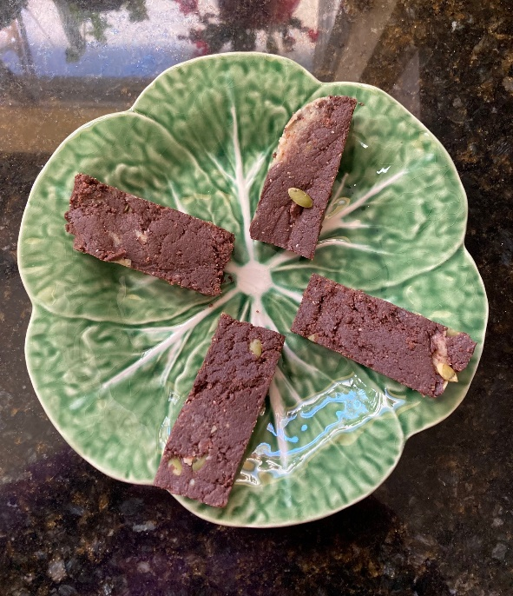
Equipment Required:
Food Processor
Rubber Spatula
7x11 Baking pan (or equivalent)
Ingredients:
2 cups Organic Raw Cashews
1 cup Vanilla Protein Powder
¼ cup Organic Maple Syrup
¼ Cup Water
½ Cup Organic Raw Cacao Powder
2 Tbs Organic Pumpkin Seeds
2 Tbs Organic shredded or flaked Coconut
Instructions:
Process the 2 (heaping) cups of cashews in food processor until smooth and there are no clumps. This takes between 5 and 10 minutes depending on your food processor.
Add the Maple Syrup and Water and pulse to blend.
Add the Protein Powder and Cacao and process until somewhat blended. It will be clumpy at this time. Use spatula to complete blending.
Add Pumpkin Seeds and Coconut and pulse. Use spatula to blend as desired.
- You can mix anything you like in addition to or in replacement of Pumpkin Seeds and Coconut. Nuts, Nibs, Cranberry Raisins, etc.
Grease the baking pan with butter or oil. I use MCT oil.
Press the mixture into the pan and smooth with the spatula.
Cover and place in refrigerator overnight.
Cut into 16 equal sized bars. I move them to a Tupperware at this point.
Keep refrigerated. They will hold up for a few hours in a backpack or golf bag though keep in cooler when transporting if possible.
Pictures of each step are shown below.
Enjoy!
Note that many people don’t know about raw Cacao. It is the raw version of Chocolate before heating and further processing and is considered a super food! Here’s an article explaining this!

Heaping 2 cups of raw organic cashews
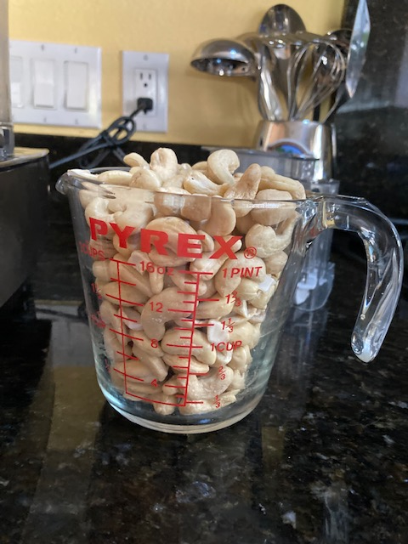

Other Ingredients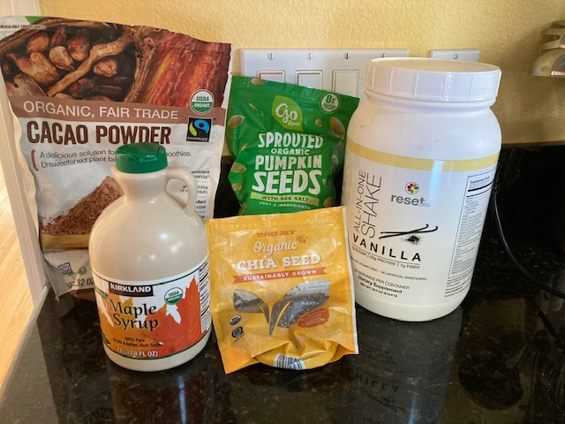

Smooth Cashew Butter
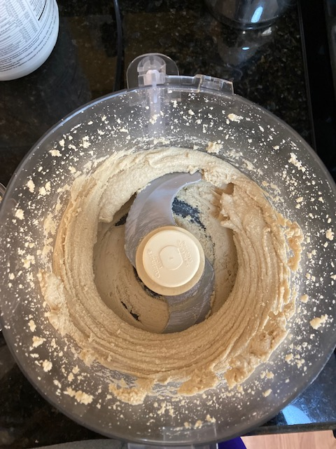

“Clumpiness” after mixing powders
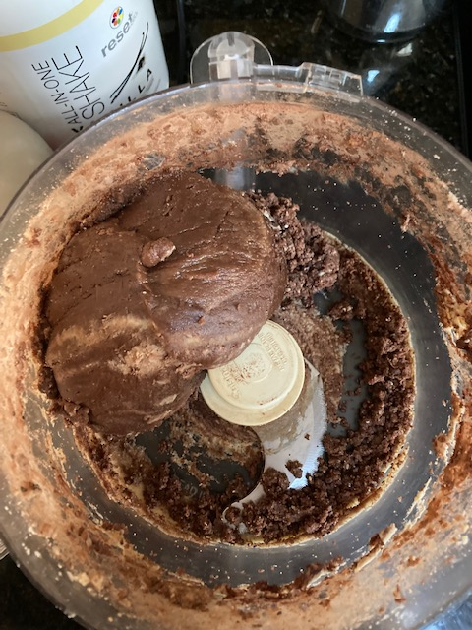

Use Rubber Spatula to mix Seeds, Nibs, Coconut..You choice!
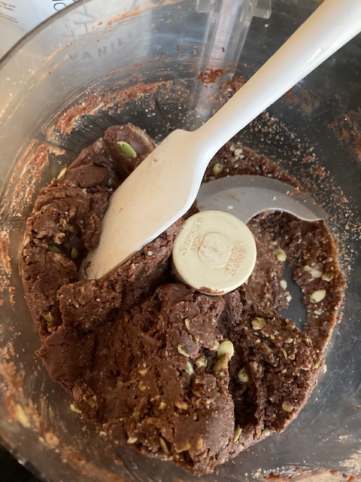

Put Into Greased Pan
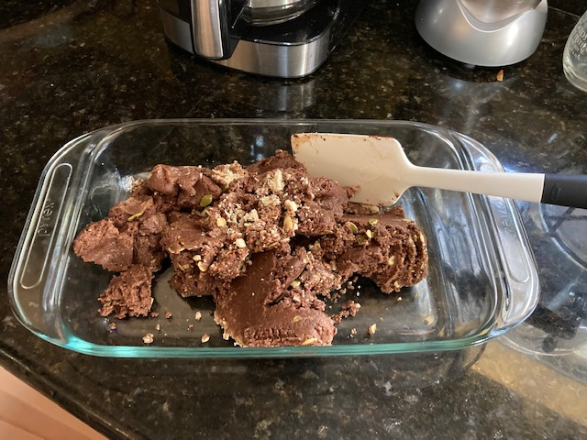

Smooth Evenly in Pan Then Put In Fridge!
