QuickStart Guide for DailyBeatHRV

Welcome!
- DailyBeatHRV provides you with an accurate assessment of your overall health and resilience. Our clinical grade algorithms measure Heart Rate Variability (HRV) and provide you with intuitive and easy to understand health status.
- If you are trying to create new habits, we recommend a daily reading so that you will know your willpower reserve for the day and can plan accordingly. Research shows that HRV is correlated with willpower. So stay on track by understanding Willpower and HRV.
- If you are keeping an eye on your overall health, do a session once a day, once a week or once a month! What is important is to choose a schedule that you can stick with!
- Since HRV has a natural 24 hour variation, try to do you sessions at the same time of the day. Otherwise you will be comparing apples to oranges. We recommend first thing in the morning before you eat or have coffee/tea.
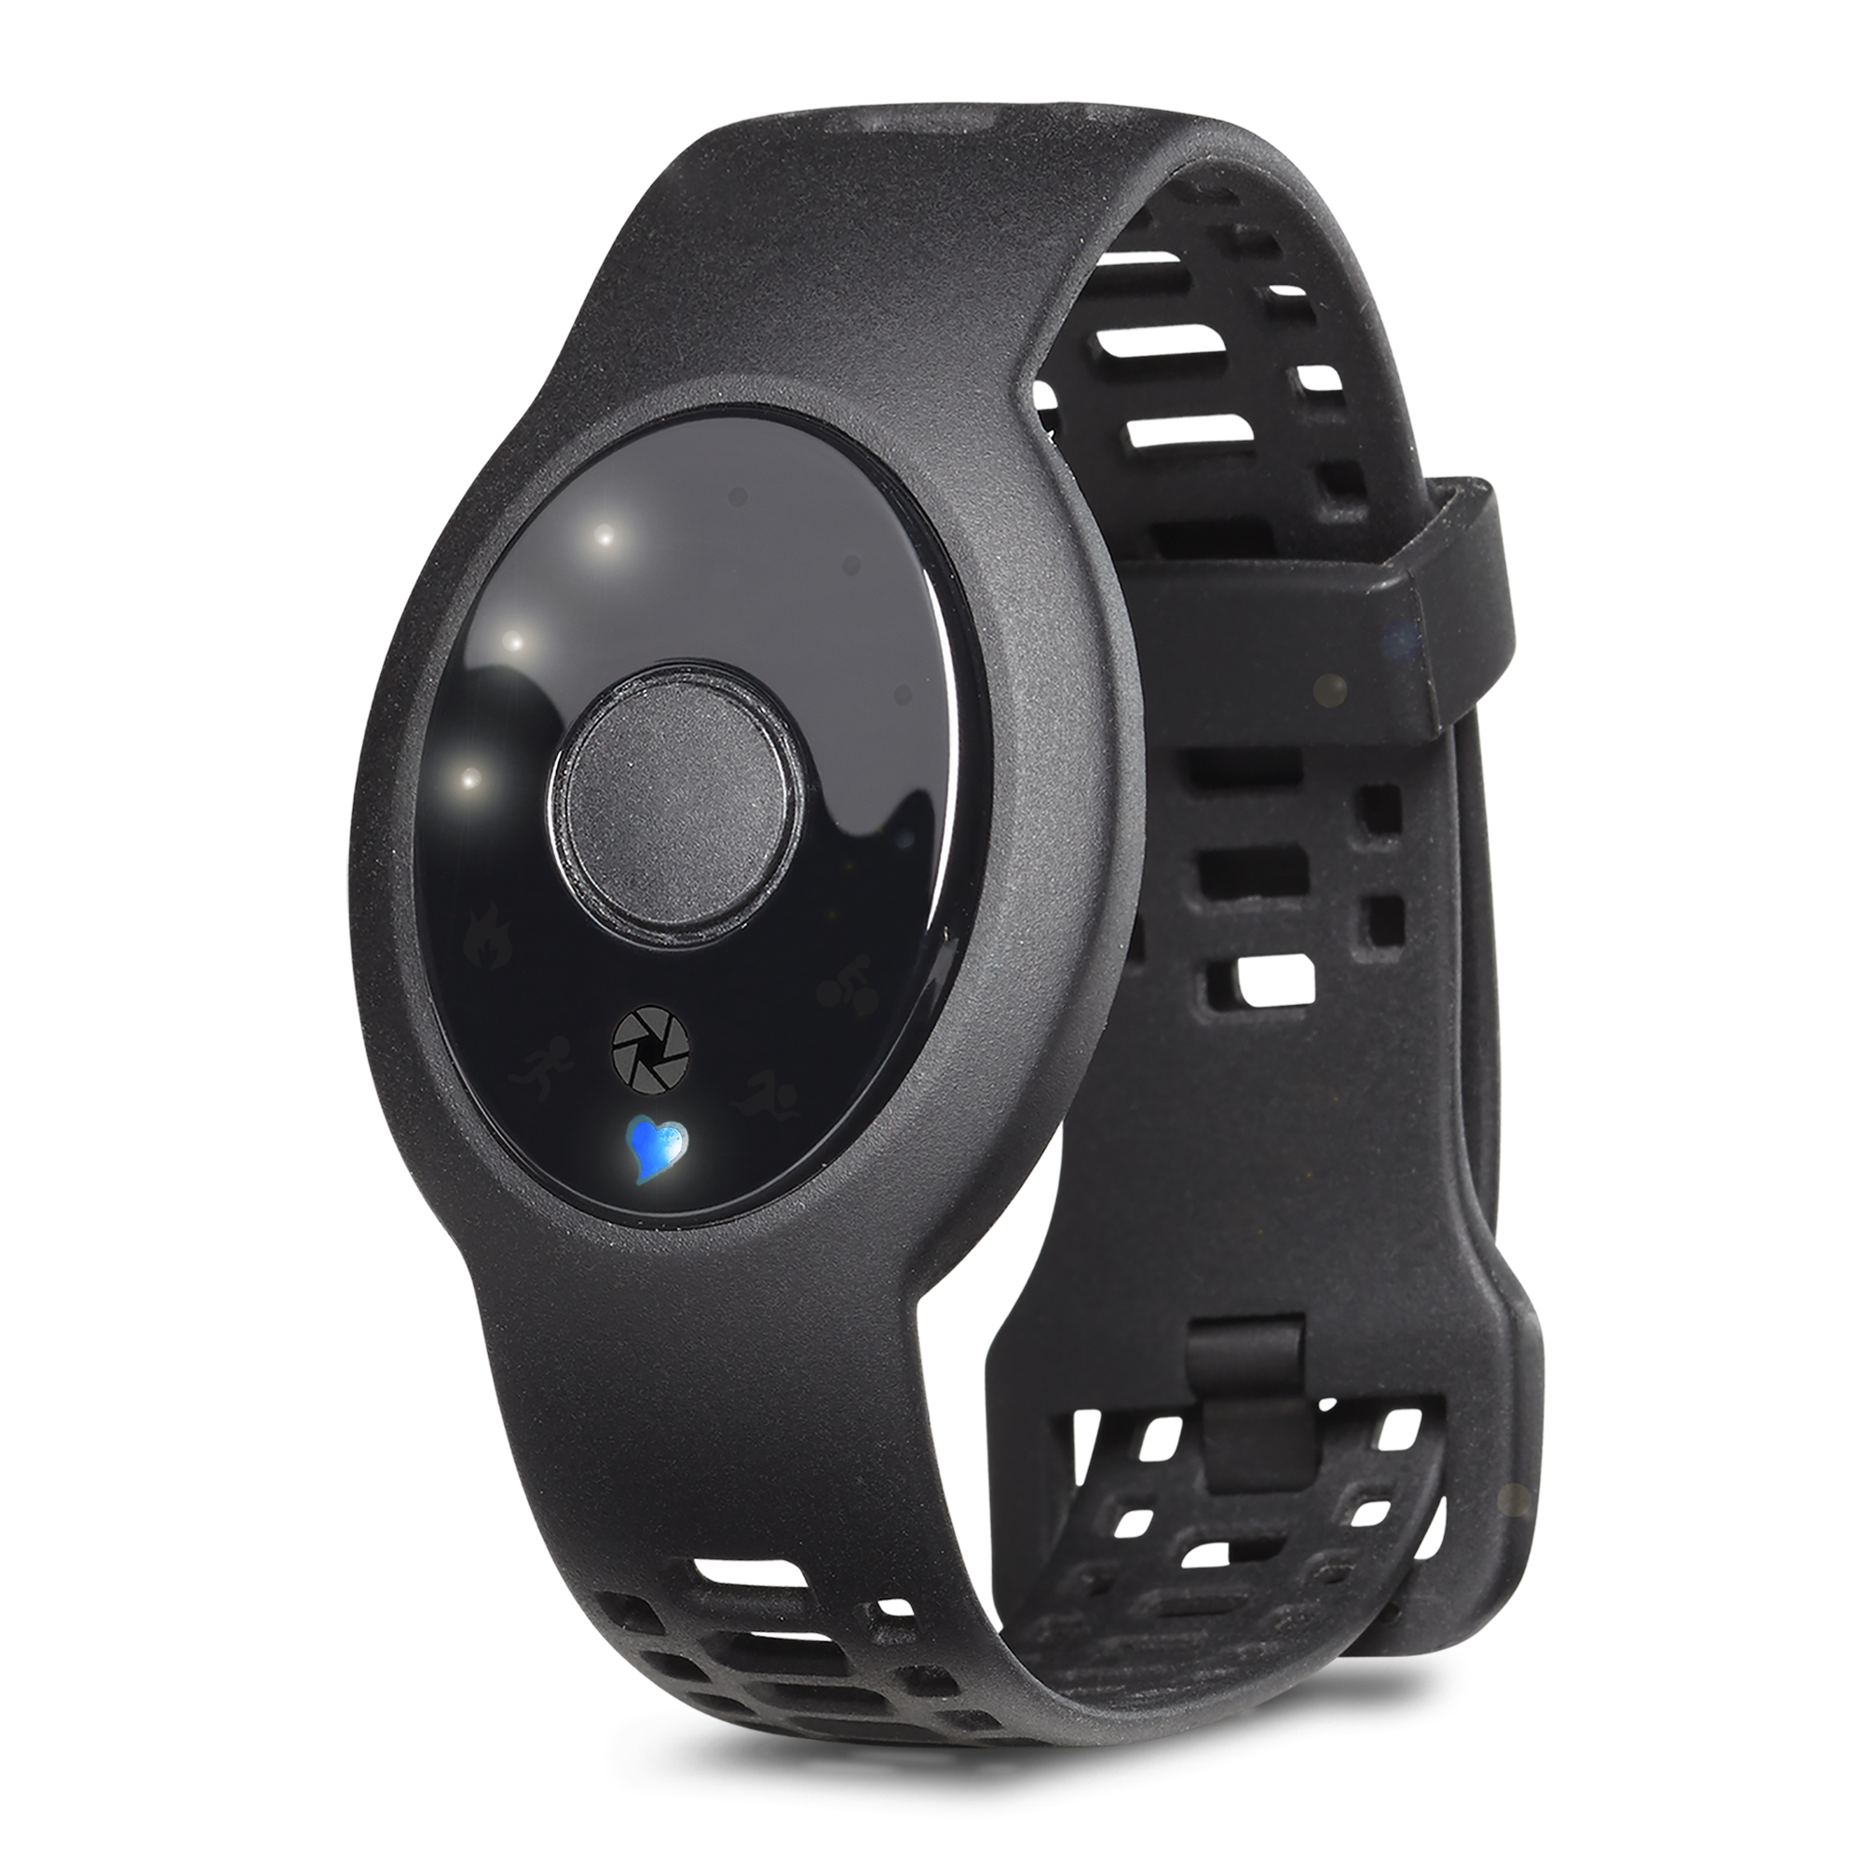
Getting Started
- You can use the Zoom Device or you can use any of our supported Bluetooth Low Energy Chest Strap Heart Rate Monitors
- Go to www.zoomhrv.com and use promo code ZOOMSB10 for $10 off the Zoom.

- Next pair the Heart Rate Monitor by selecting the General icon 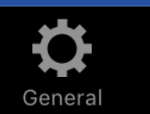 on the main screen then select Heart Rate Monitors -> Bluetooth Smart.

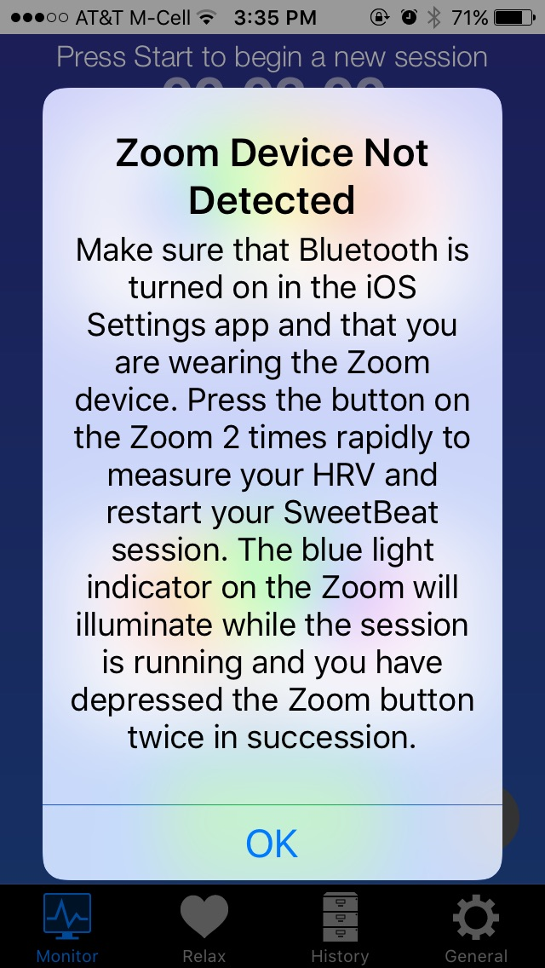
- The app will scan for your monitor. When it is displayed in the list, tap it to pair. To pair the Zoom device press the button 3 times on the Zoom. If the Zoom is not paired you will see this pop up screen when you run a session.

- Return to the Monitor screen and press Start. If you are using the Zoom device, press the Zoom button two times quickly for HRV mode and the Zoom blue indicator light will turn on.
  - Note if this is your first time, you will be prompted to set your daily reminder time. You may turn this off later by selecting the General Tab -> App Settings.
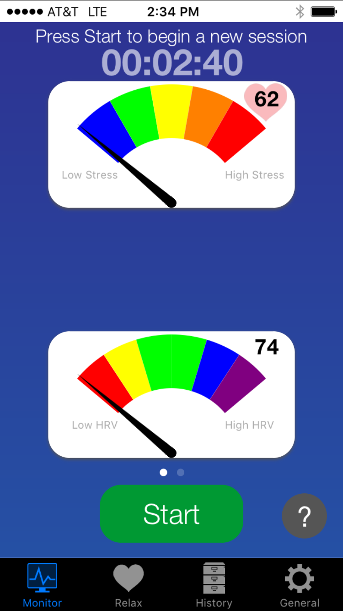
- DailyBeatHRV will attempt to connect to your Heart Rate Monitor and you will see the “Connecting to Heart Rate Monitor/Listening for Heart Beat” message at the top of the screen
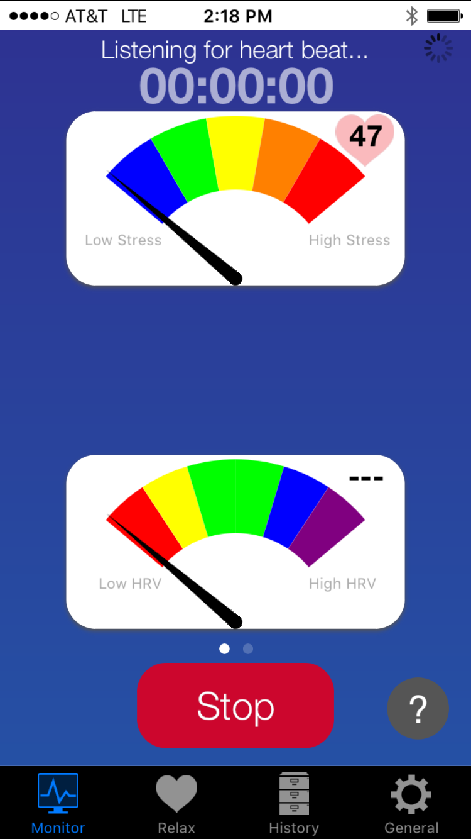

- After it is connected to your heart rate monitor, it will begin collecting data for up to 45 seconds. The ECG animation shows your heart beat intervals and the heart your heart rate!
- You will see “Waiting for more data” at the top of the screen. This is the clinical grade processing in action!
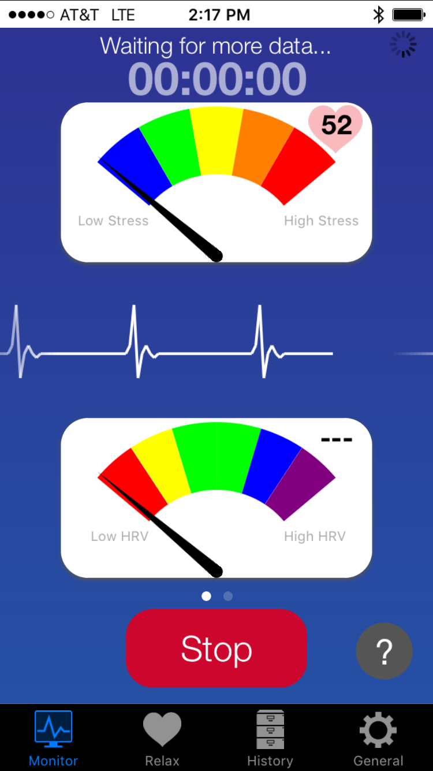
- Once enough data has been collected, your stress level and HRV will be displayed and the session timer will count down to the end of the session. You may terminate your session early (not recommended) by pressing Stop.
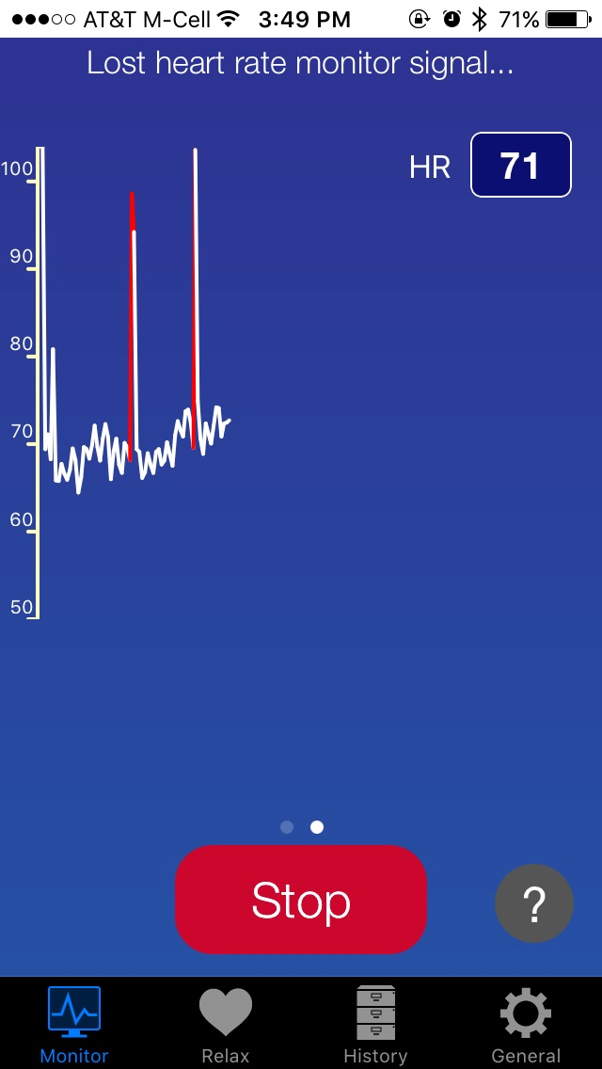
- If you are using the Zoom, use must remain perfectly still for 2 1/2 to 3 minutes until the Zoom blue indicator light turns off. If you talk, turn your head, or move your body in any way the HRV measurement will be inaccurate. The Zoom optical sensor is highly sensitive to movement for HRV readings. Movement during your session will result in inaccurately high HRV results.

- You can switch to your beat to beat heart rate screen by swiping right to left and return to the main screen by once again swiping right to left. Your current heart rate is shown in the box at the upper right of the screen.
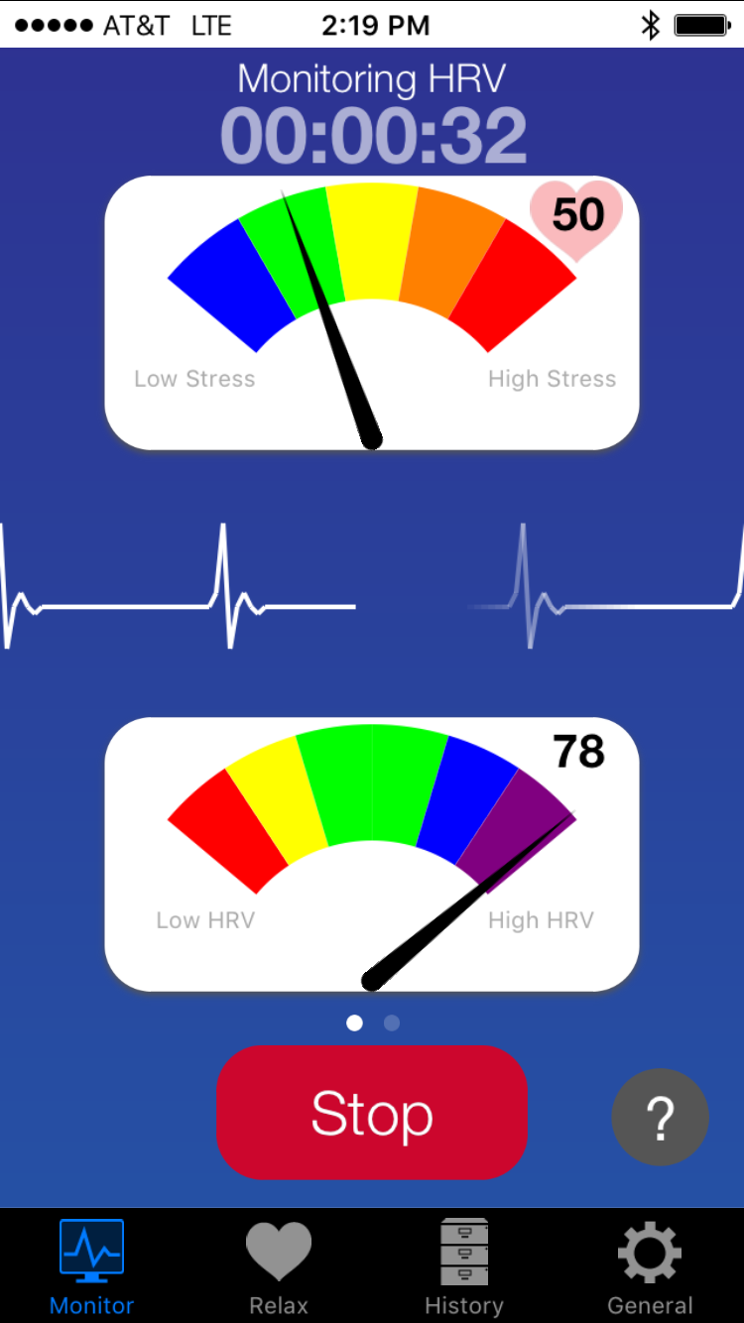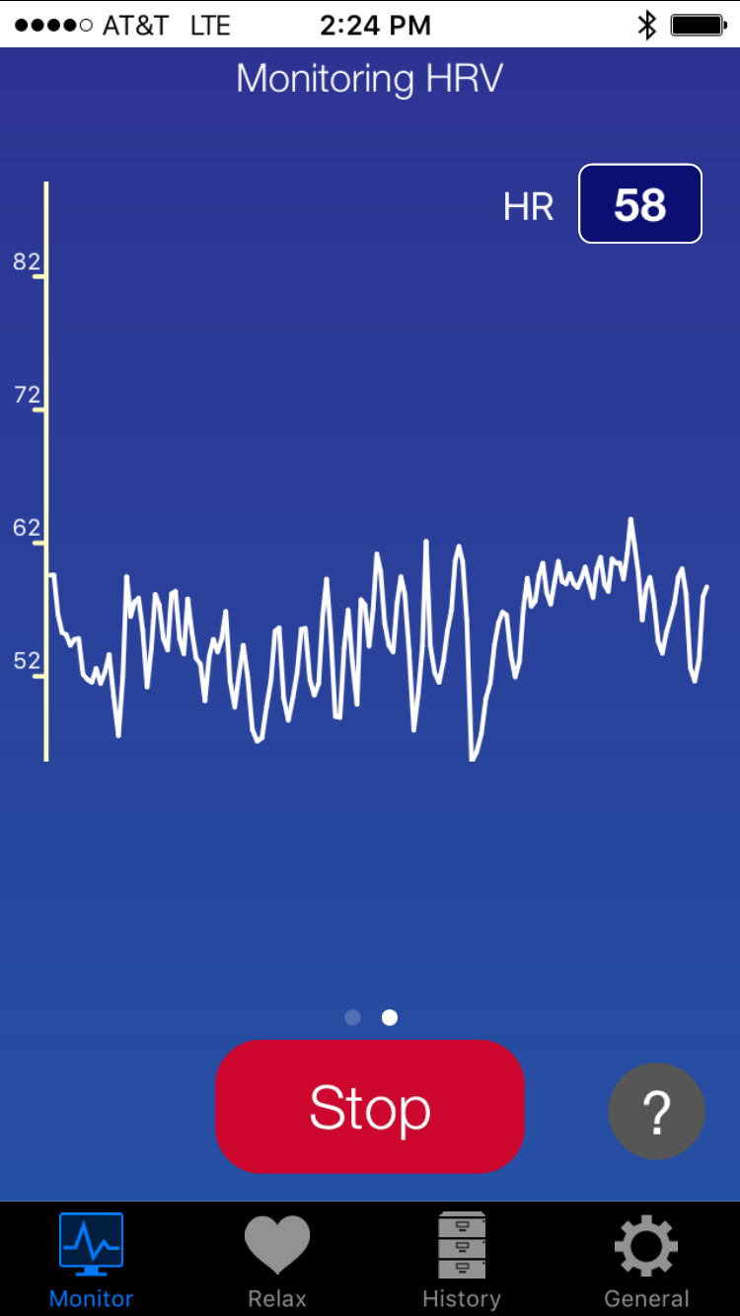
- At the end of the 3 minute session, the session summary will automatically be displayed. Select “Save Session” at bottom of Session Summary screen.
- A “Tag Your Session” screen will appear and allow you to select from the canned tags or type in your own custom tag.
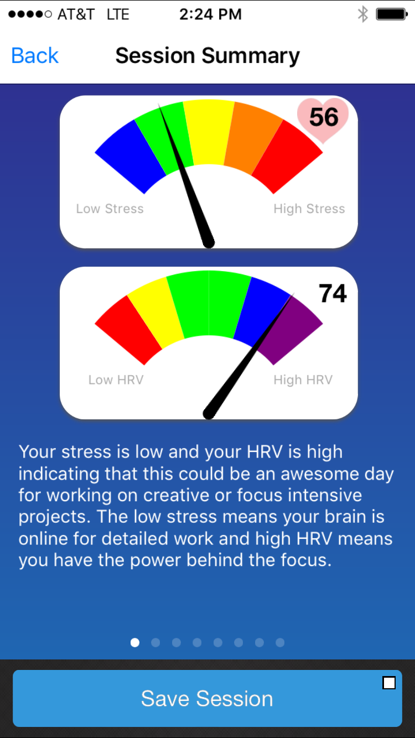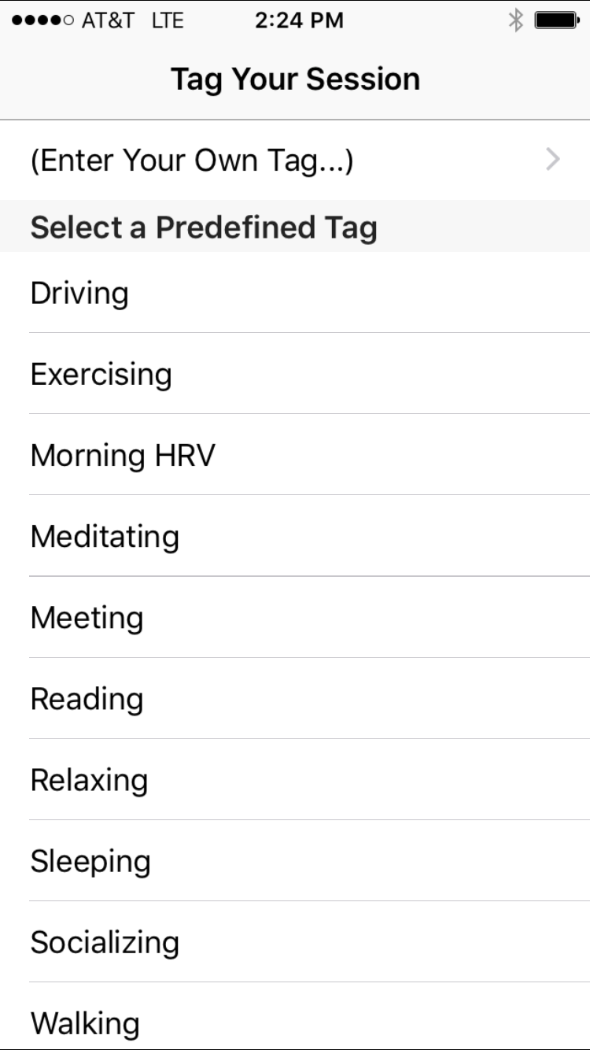
- Assuming you have created an account and logged in, your session will be automatically uploaded as indicated by the green square in the upload button. If you are not logged in it will be saved on your phone/tablet and you can upload it later.
- You can share your session on Facebook and Twitter or email the results by selecting the “Share” button.
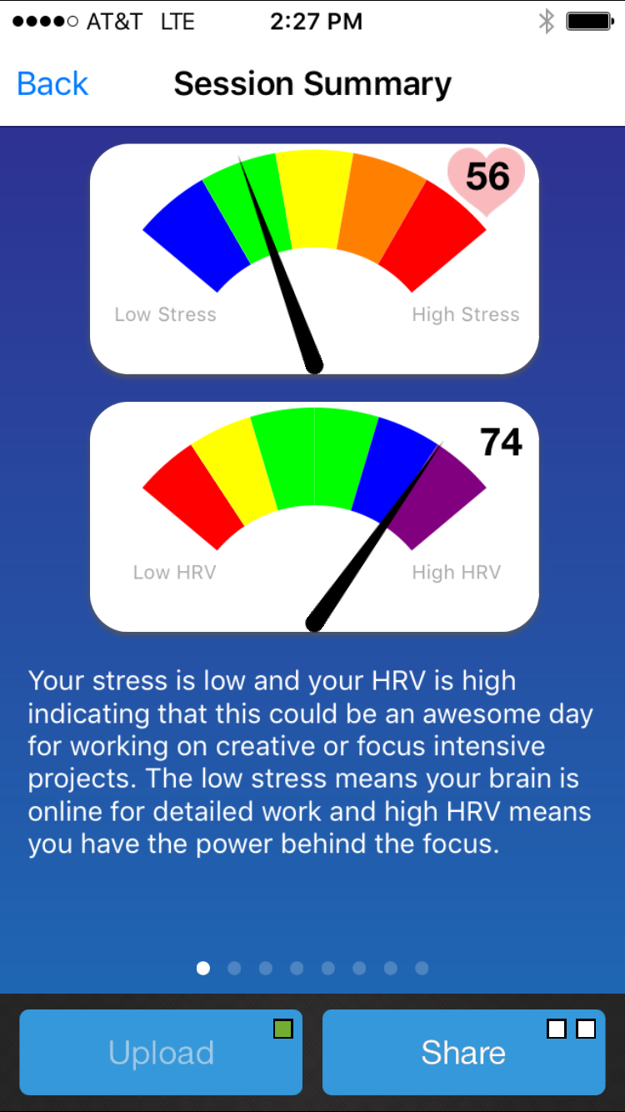

Session Summary Reports
- There are 4 session summary screens which can be accessed by swiping right to left.
- The first session summary screen shows your Stress and your HRV.
  - Your stress is the balance of “Fight or Flight” and “Rest and Digest” branches of the nervous system.
    - Red = Increased Fight or Flight -> Blue = Increased Rest and Digest
  - Your HRV score is a number from 0 – 100.
    - High HRV is usually optimal
    - Since HRV varies between age and gender, your score has been adjusted based on the age and gender you entered.
- Now swipe right to left to see the second summary screen – Your daily Willpower Score
  - This screen shows your daily willpower compared to yourself (in contrast to the other summaries that compare to others of your age and gender).
  - The blue line shows your daily scores and the yellow line shows your personalized reference line.
  - Your daily recommendation will be based on where your score ranks relative to your reference line.
  - You need at least 4 daily sessions for this chart to make sense.
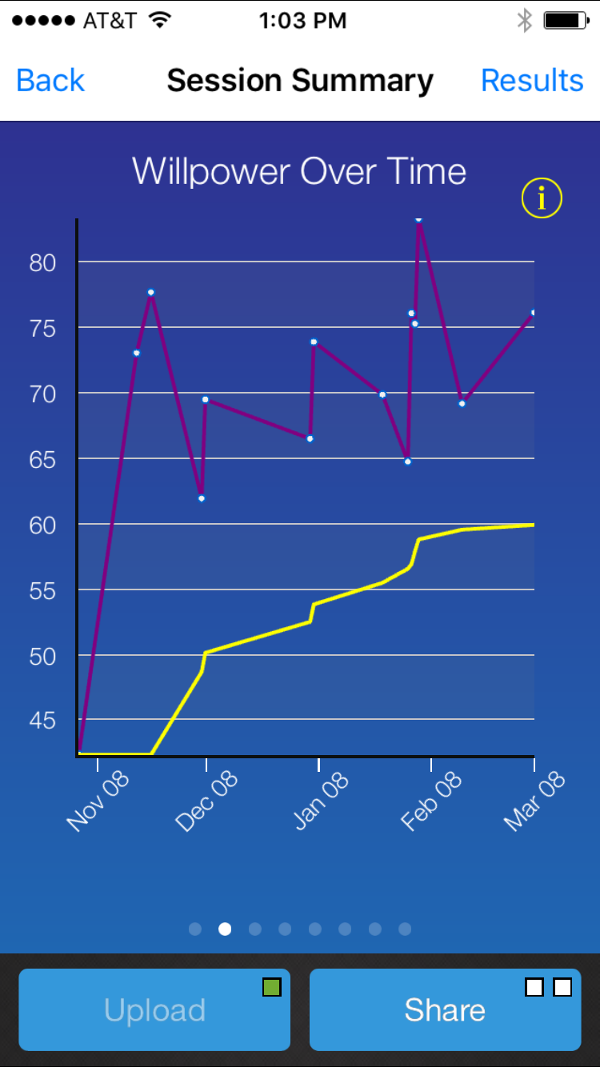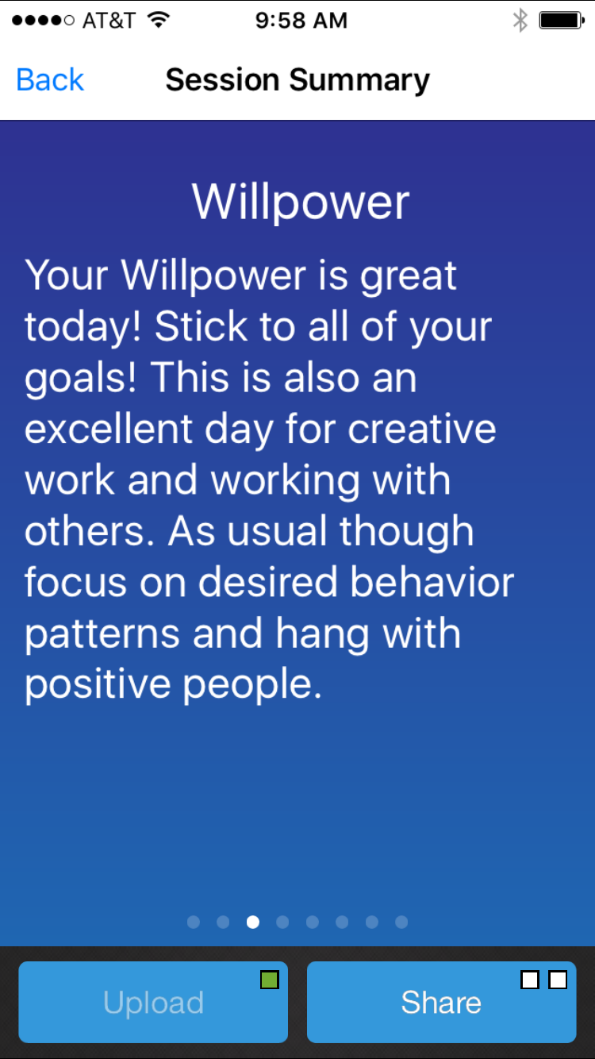
- Now swipe right to left to see the third summary screen – Power Balance Screen
  - Your “Power” can be compared to a stereo system. A low power 50 watt amplifier will generate distorted sound at high volumes. A high power 250 watt amplifier will produce clean sound at high volumes.
  - Your Power level is similar. On a high power day, you will be able to stay centered and cool headed when life gets hectic or challenging. On a low power day you may be less able to stay balanced in the face of difficulty.
  - Your Balance is like the left and right speakers of the stereo. Your right speaker is you “Fight or Flight” response and your left speaker is your “Rest and Digest” response.
  - Shows you where you are compared to others your age and gender.
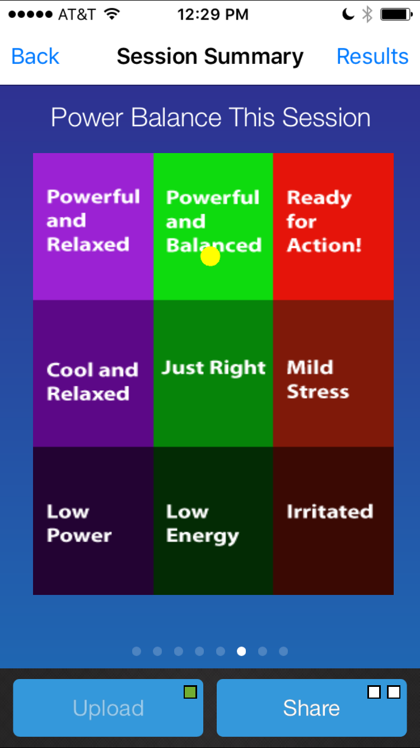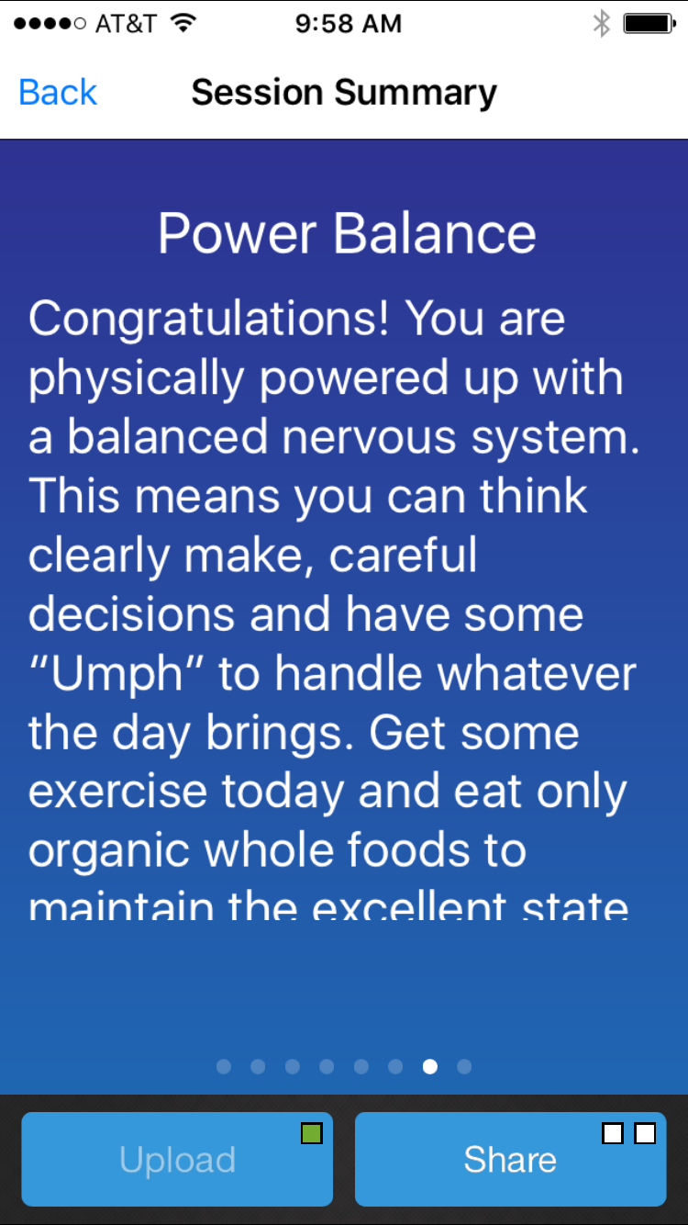
- Now swipe right to left to see the Fourth summary screen – Your Resilience Chart
  - Your “Resilience” is a measure of your ability to recover from physical, mental or emotional difficulties.
  - The Resilience chart is shows where you are compared to the average healthy person in your age group and gender.
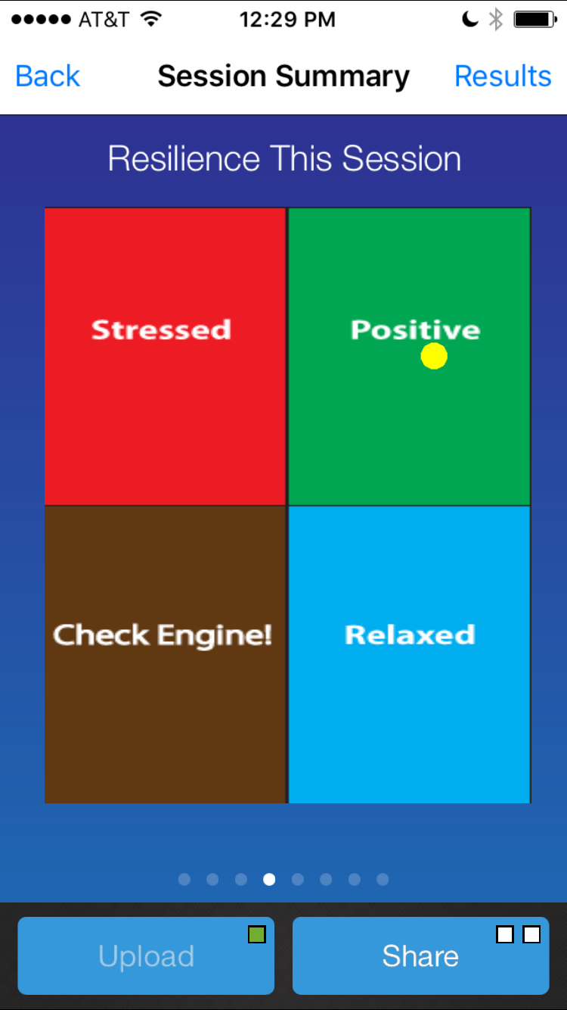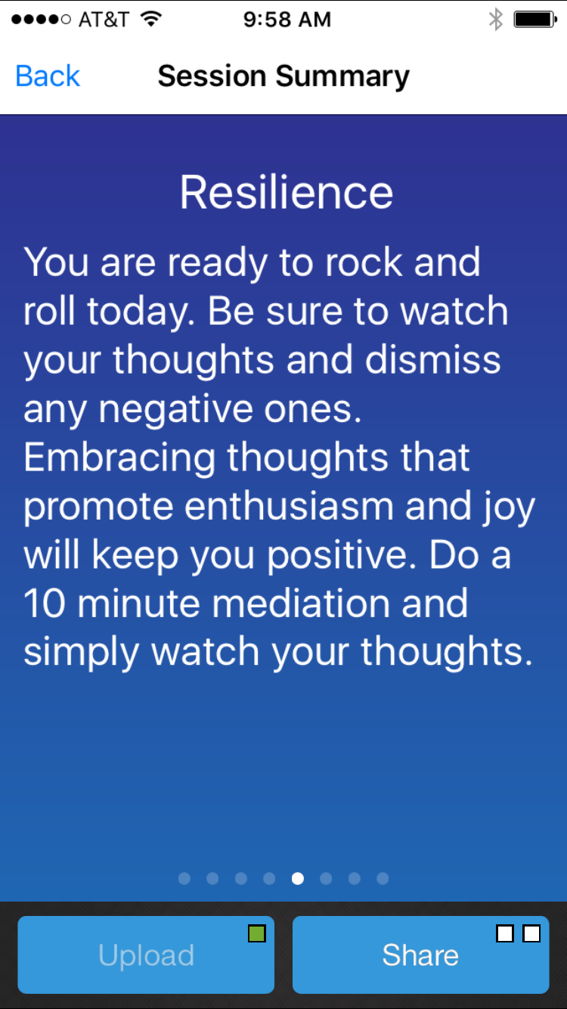
History Charts
- Select the Back button to return to the main screen then select The “History” tab at the bottom.
- At the top are 2 buttons, the Sessions button which displays the individual sessions and the “Charts” button which shows the data from ALL of your sessions.
- The Sessions screen shows all your individual sessions with the time, date and tag. The “arrow”, Facebook and twitter icons tell if the session has been uploaded, shared on Facebook or tweeted. If it is highlighted, it has been uploaded or shared.
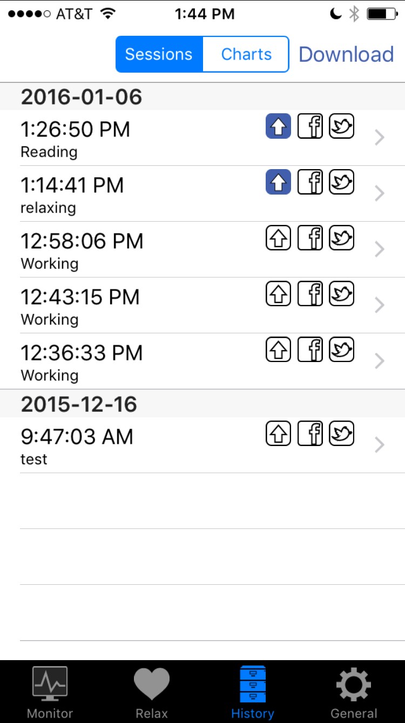
- We already described the “Session” reports so let’s look at the “Charts” reports by pressing the Charts button.
- The first screen is your “Willpower” screen which is the same as shown in the session summary. This screen will include all your sessions to date.
- Swipe right to left to see your Power and Balance and Resilience charts. Each session is shown as an individual dot.
- We all have low days from time to time. These 2 charts provide a high level view of your health.
- If you are always in the “Check Engine” box, then a checkup may be in order. If you are always “Irritated”, some stress reduction habits will be very beneficial.
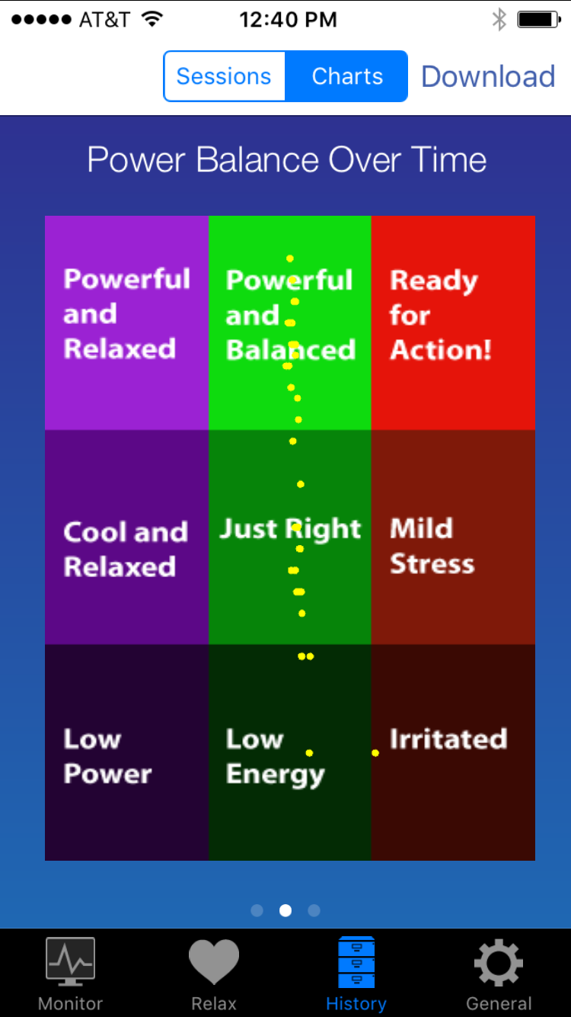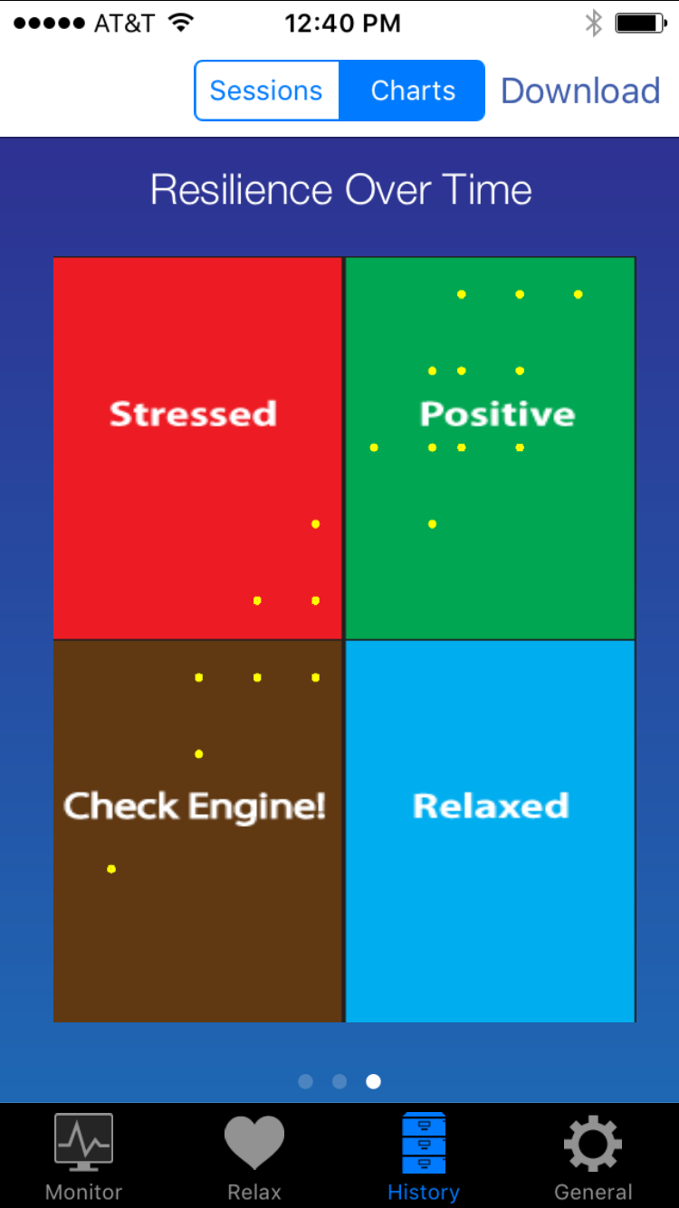

Advanced Information
DailyBeatHRV keeps track of the date! The first session of the day is meant to be done first thing in the morning in order to provide a daily Willpower score. In order to compare apples to apples, it should be done around the same time of day and for the same length of time (thus the 3 minute timer). Any subsequent sessions that same day will not be timed and will not be included in your Willpower score. They will be included in your Resilience and Power and Balance charts. Note that any subsequent sessions should be AT LEAST 3 minutes long to ensure accuracy.
Thank you and BeatHealthy!
DailyBeatHRV is not a medical device or medical application.
SweetWater Health, LLC does not provide medical advice, diagnosis or treatment.

